LAB EXPERIMENT RECORD
SET 21: ENERGY CONSUMPTION ANALYSIS
Department | AIDS
Course Code / Course Name | DSA0601 / Data Handling and Visualization
Experiment | Data Visualization using R
Name | B. Pallavi
Register Number | 192424243
Date | 15 October 2026
Day | Thrusday

AIM: To analyze energy consumption, temperature, cost, and renewable energy usage using R.
Dataset
energy <- data.frame(
Sector=c("Residential","Commercial","Industrial",
"Residential","Commercial","Industrial"),
Region=c("North","South","West","East","North","South"),
Month=c("Jan","Jan","Feb","Feb","Mar","Mar"),
Temperature=c(15,24,20,18,28,30),
Units_Consumed=c(320,540,880,350,610,920),
Cost=c(2100,3600,5900,2300,4100,6200),
Renewable_Usage=c(22,18,12,25,20,15),
Peak_Hours=c(4,6,8,5,7,9)
)
print(energy)
Program 1: Histogram and Density Plot
hist(energy$Units_Consumed,
probability=TRUE,
col="skyblue",
main="Energy Consumption Distribution",
xlab="Units Consumed")

lines(density(energy$Units_Consumed),
col="red", lwd=2)
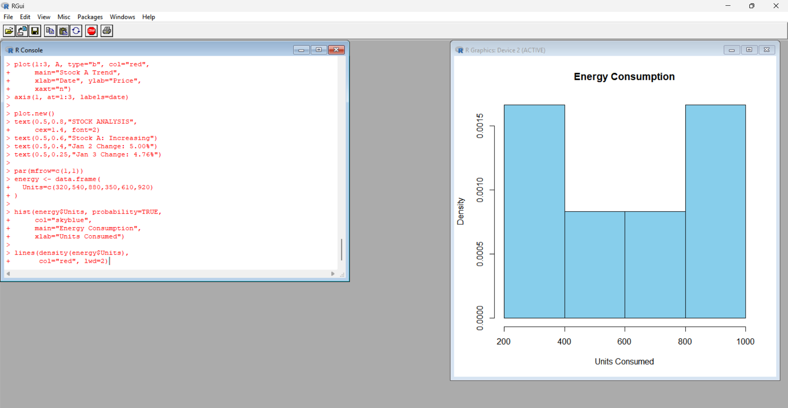
Output: Histogram with a red density curve.
Observation: Consumption ranges from 320 to 920 units.
Program 2: Bubble Plot
symbols(energy$Temperature,
energy$Units_Consumed,
circles=energy$Peak_Hours/12,
inches=0.25,
bg="lightblue",
main="Temperature vs Energy Consumption",
xlab="Temperature",
ylab="Units Consumed")
text(energy$Temperature,
energy$Units_Consumed,
labels=energy$Sector,
pos=3, cex=0.6)
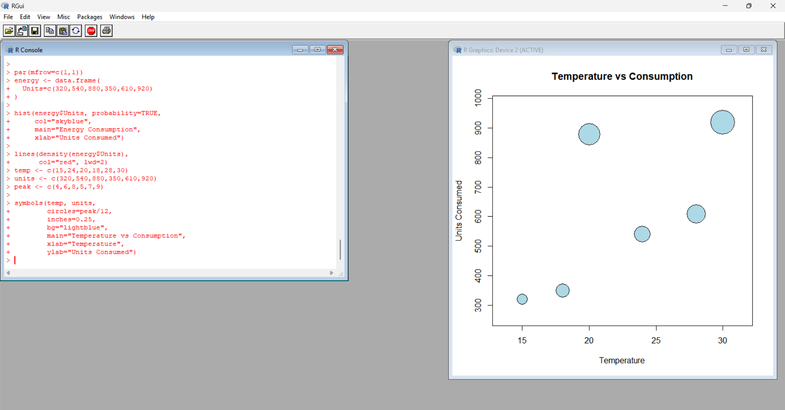
Output: Bubble chart comparing temperature and energy consumption.
Observation: The industrial records show higher energy consumption than the residential records.
Program 3: Average Renewable Usage by Sector
avg <- aggregate(
Renewable_Usage ~ Sector,
data=energy,
FUN=mean
)
print(avg)
barplot(avg$Renewable_Usage,
names.arg=avg$Sector,
col=c("green","orange","skyblue"),
main="Average Renewable Energy Usage",
xlab="Sector",
ylab="Usage (%)")
Output:
Sector | Average Renewable Usage
Commercial | 19%
Industrial | 13.5%
Residential | 23.5%
Observation: Residential has the highest average renewable energy usage.
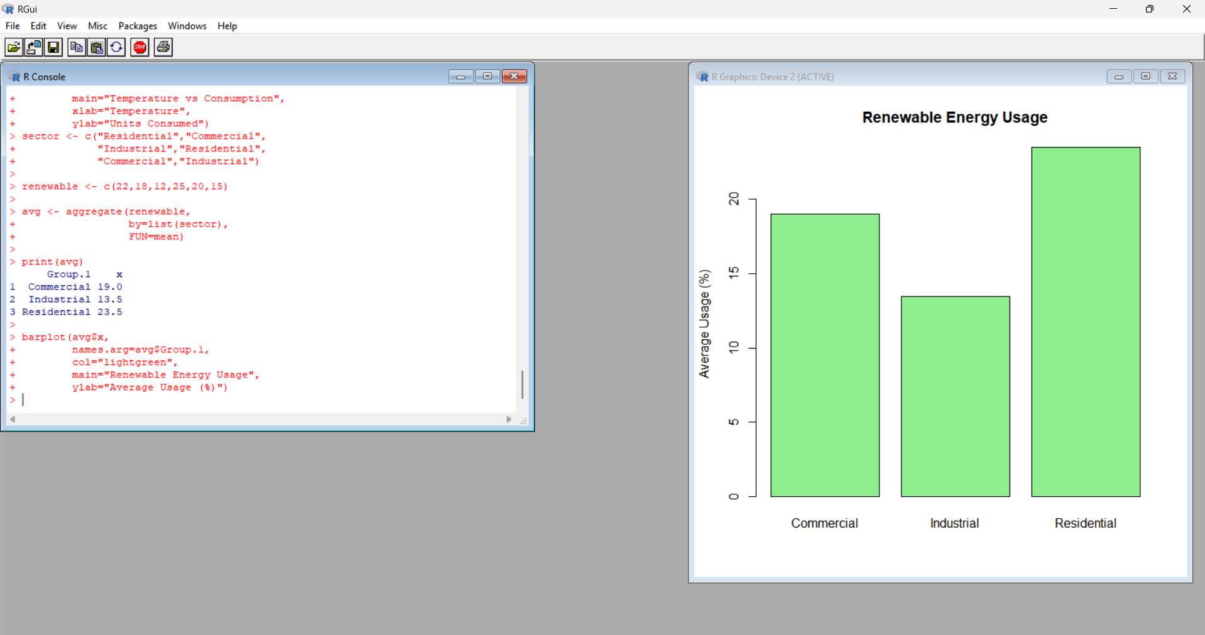
Program 4: Energy Consumption Dashboard in R
par(mfrow=c(2,2))

plot(1:6, energy$Units_Consumed,
type="b", col="blue", pch=19,
main="Energy Consumption",
xlab="Record", ylab="Units")

barplot(energy$Cost,
names.arg=energy$Sector,
col="orange",
main="Energy Cost",
ylab="Cost")

plot(energy$Temperature,
energy$Units_Consumed,
pch=19, col="red",
main="Temperature vs Consumption",
xlab="Temperature",
ylab="Units Consumed")

barplot(avg$Renewable_Usage,
names.arg=avg$Sector,
col="green",
main="Renewable Usage",
ylab="Average (%)")

par(mfrow=c(1,1))
Output: A four-panel dashboard displaying energy consumption, cost, temperature relationship, and renewable energy usage.
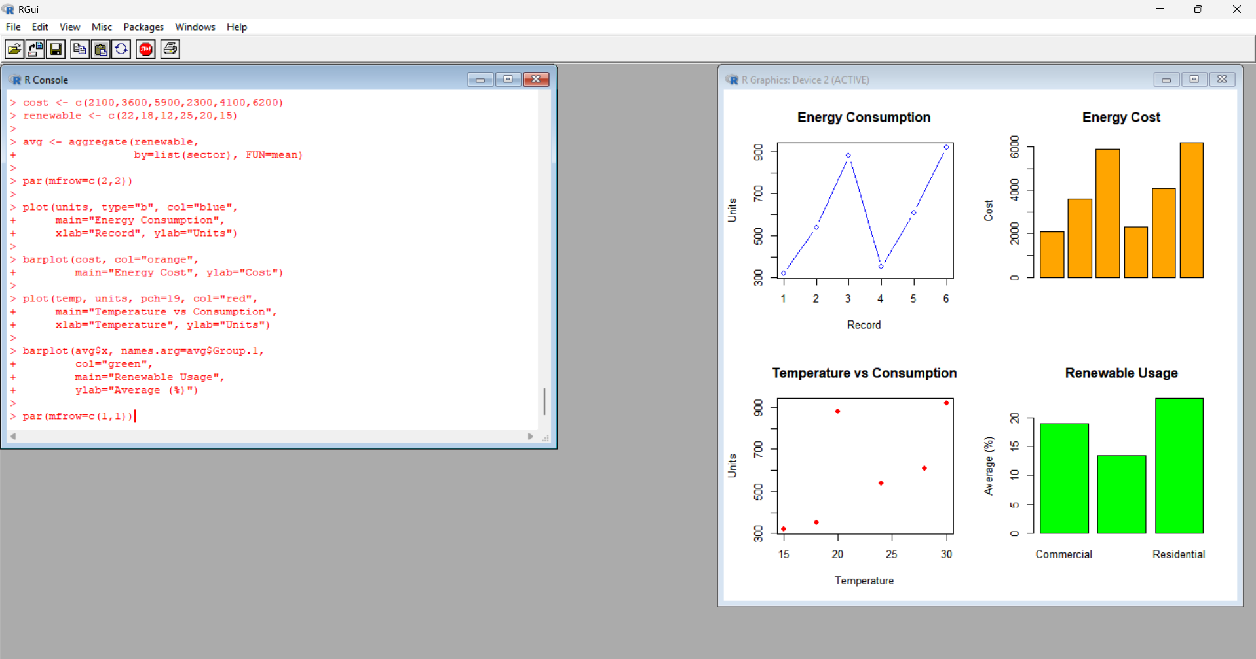
RESULT
Energy consumption data were analyzed using histograms, density plots, bubble charts, bar charts, and a dashboard in R.

